A class diagram is a type of diagram which is part of a unified modeling language (UML) that defines and gives the overview and structure of the system in terms of classes, methods, attributes, and the relationship amongst the different classes.

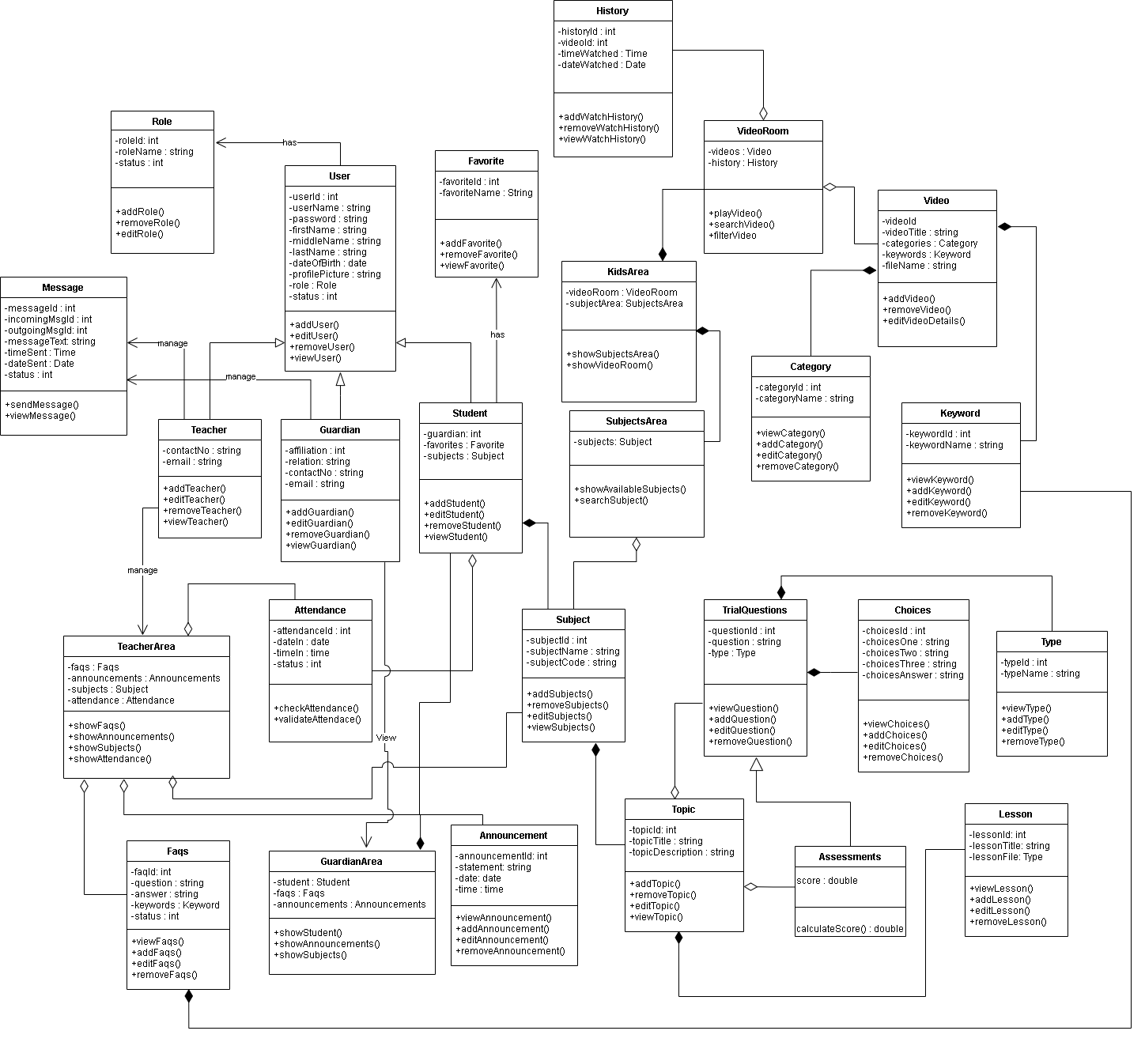

**Figure 1. Class Diagram**

Figure 1 shows all the classes that will be used on the Web-based Computer-Aided Instruction for Nursery Students and their corresponding methods and the relationships and the attributes of each class in the diagram. The diagram consists of class for Role, User, Teacher, FAQs, Attendance, Parent, Student, GuardianArea, TeachersArea, Announcement, Subject, Subjects Area, Subject Grade, KidsArea, Video, VideoRoom, Category, Keywords, TrialQuestion, Topic, Assessments, and Choices.

The parents, student, and teacher inherit the User table’s instances or properties which provide the needs for users, such as username, password, first name, middle name, last name, sex, date of birth, profile, picture, role, and status of an account. The parent has property affiliation, email, and contact number. The teacher has properties of email and contact number. While the student contains the section and their parent.

The kid’s area class has a video room and subject area. The video room class has videos and a history class. The subject area class has subjects. The video class contains a property video title, category, keywords, and file name. The history class contains a property of video, time watched and date watched. The subject class is composed of topics and has a property of subject name and subject code. While the topic class contains a topic title and topic description. The assessment class has score property and inherits all properties of the trial question class that are composed of choices and has a property of question.

The teacher manages the teacher’s area class which contains subjects, announcements, FAQs, and attendance of the student. The parent has an access to view the parent’s area class that contains the student information, faqs, announcements. They both manage the message class to contact each other if they have questions. It depicts the system's overall presentation, as well as the various objects included in the proposed system, as well as their relationships and how objects interact with one another.

Use case diagrams are a visual representation of a system's requirements, including internal and external factors. The roles of the actors are portrayed across these diagrams. The purpose of this diagram is to provide an overview of the actors and their roles, functionalities, as well as dependencies presented in the diagram.

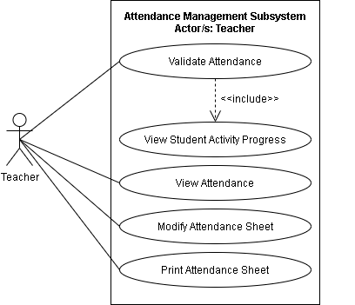

**Figure 2. Use Case Diagram for Attendance Management Subsystem**

Figure 2 shows the Use case diagram for the Attendance Management Subsystem. The illustration shows the capabilities of the teacher. The teacher can validate attendance which includes the view student’s activity progress, student’s attendance, modify attendance sheet, and print attendance sheet.

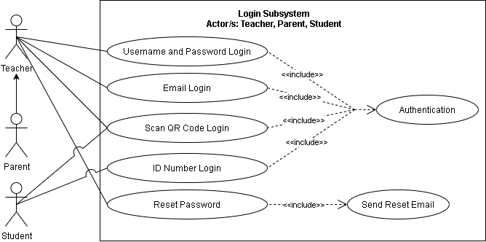

**Figure 3. A Use Case Diagram for Login Subsystem**

Figure 3 shows the Use case diagram for the Login Subsystem. The illustration shows the capabilities of teachers, parents, and students. The teacher and parents have access to username, password, e-mail, QR code, and reset password which is the primary authentication of the system. Otherwise, the student can only access the system by scanning the QR code and by its unique ID number.

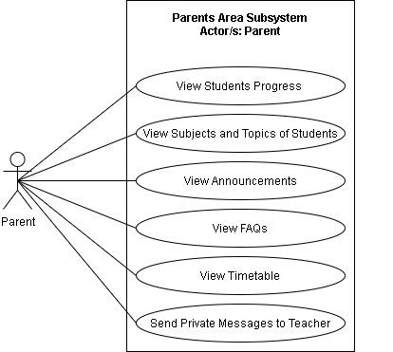

**Figure 4. Use Case Diagram for Parents Area Subsystem**

Figure 4 shows the Use case diagram for the Parents Area Subsystem. The illustration shows the capabilities of parents. The parents have access to view student’s progress, view student’s subjects and topics, view announcements, view FAQs, view Timetable, and send private message to teacher.

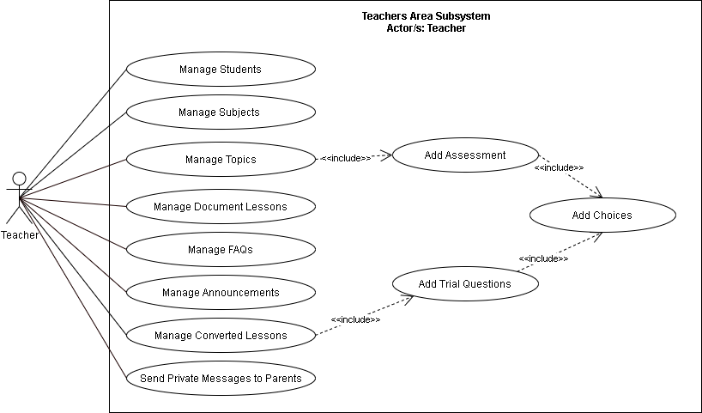

**Figure 5. Use Case Diagram for Teachers Area Subsystem**

Figure 5 shows the Use case diagram for the Teachers Area Subsystem. The illustration shows the capabilities of teachers. The teachers have access to Manage of Subjects, Manage topics which include adding of assessment and adding of choices, Manage Document Lesson, Teachers can also manage FAQs, manage announcements, and manage student cards.

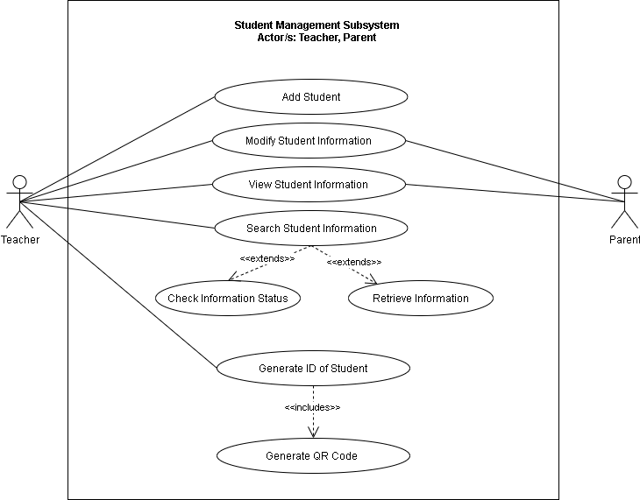

**Figure 6. Use Case Diagram for Student Management Subsystem**

Figure 6 shows the Use case diagram for the Student Management Subsystem. The illustration shows the capabilities of teachers and parents. The teachers have access to Log in which includes authentication, student registration, modify student information, view student information, search student information, manage student cards, and view student card. Otherwise, the parent has access to Log in which includes authentication, modify student information, view student information, and view student card.

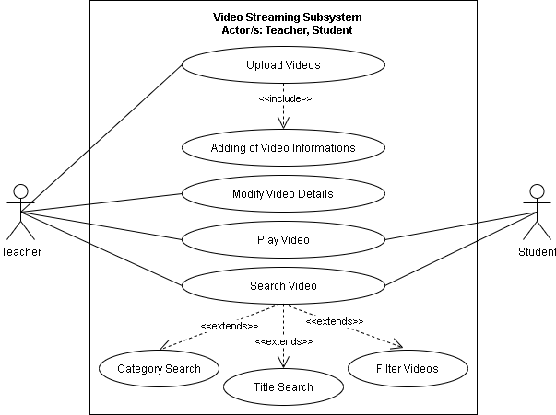

**Figure 7. Use Case Diagram for Video Streaming Subsystem**

Figure 7 shows the Use case diagram for the Video Streaming Subsystem. The illustration shows the capabilities of teacher and student. The teachers can upload videos that include its information, modify video details, search video and play video. Otherwise, the student can only search for video and play videos.

**Table 2. Use case analysis for Attendance Management Subsystem**

|  |  |  |  |
| --- | --- | --- | --- |
| **Actor/s** | **Event** | **Trigger** | **System Response** |
| **Teacher** | Validate Attendance | Teacher logs in | Display log-in form |
| **Teacher** | View Student Activity Progress | Teacher views the student activity progress | Display the student activity progress |
| **Teacher** | View Attendance | Teacher views the attendance | Display the attendance |
| **Teacher** | Modify Attendance Sheet | Teacher modifies the attendance sheet | Update the attendance sheet |
| **Teacher** | Print Attendance Sheet | Teacher prints attendance sheet | Print the attendance sheet |

**Table 3. Use case analysis for Login Subsystem**

|  |  |  |  |
| --- | --- | --- | --- |
| **Actor/s** | **Event** | **Trigger** | **System Response** |
| **Teacher, Parent** | Username and Password Login | Teacher or Parent enters username and password login | Display username and password form |
| **Teacher, Parent** | E-mail Login | Teacher or Parent enters e-mail login | Display e-mail form |
| **Teacher, Parent, Student** | Scan QR Code Login | Teacher, Parent or Student scans QR code to login | Display the QR code form |
| **Student** | ID Number Login | Student enters ID number to login | Display the ID number form |
| **Teacher, Parent** | Reset Password | Teacher or Parent resets the password of the student | Shows a reset password field |

**Table 4. Use case analysis for Parent Subsystem**

|  |  |  |  |
| --- | --- | --- | --- |
| **Actor/s** | **Event** | **Trigger** | **System Response** |
| **Parents** | View Students Progress | Parent views students progress | Display students progress |
| **Parents** | View Subjects and Topic of Students | Parent views the subjects and topic of student | Display subject and topic of student |
| **Parents** | View Announcements | Parent views announcements | Display announcement |
| **Parents** | View FAQs | Parent views FAQs | Displays the FAQS |
| **Parents** | View Timetable | Parent views timetable | Display the timetable |
| **Parents** | Send Private Messages to Teacher | Parent sends messages to teacher | Display message box |

**Table 5. Use case analysis for Teachers Area Subsystem**

|  |  |  |  |
| --- | --- | --- | --- |
| **Actor/s** | **Event** | **Trigger** | **System Response** |
| **Teacher** | Manage Students | Teacher manages student | Update the students list |
| **Teacher** | Manage Subjects | Teacher manages subjects | Updates students subject |
| **Teacher** | Manage Topics | Teacher manages topic | Updates the topic |
| **Teacher** | Manage Document Lessons | Teacher manages document lessons | Updates document lesson |
| **Teacher** | Manage FAQs | Teacher manages FAQ’s | Update the FAQs |
| **Teacher** | Manage Announcement | Teacher manages announcement | Update the announcement |
| **Teacher** | Manage Converted Lessons | Teacher converts the lesson | Converts the lesson from the teacher |
| **Teacher** | Send Private Messages to Parents | Teacher sends messages to teacher | Display message box |

**Table 6. Use case analysis for Student Management Subsystem**

|  |  |  |  |
| --- | --- | --- | --- |
| **Actor/s** | **Event** | **Trigger** | **System Response** |
| **Teacher** | Add Student | Teacher adds student | Updates the database of student |
| **Teacher, Parents** | Modify Student Information | Teacher or Parent modifies student’s information | Update the student information |
| **Teacher, Parents** | View Student Information | Teacher or Parent views the student’s information | Display the student information |
| **Teacher** | Search Student Information | Teacher searches student’s information | Display Check Information Status and Retrieve Information |
| **Teacher** | Generate ID of student | Teacher generates ID of student | Generate printable student ID |

**Table 7. Use case analysis for Video Streaming Subsystem**

|  |  |  |  |
| --- | --- | --- | --- |
| **Actor/s** | **Event** | **Trigger** | **System Response** |
| **Teacher** | Upload Videos | Teacher uploads video | Uploads video to the system |
| **Teacher** | Modify Video Details | Teacher modifies video details | Updates video details |
| **Teacher, Student** | Play Video | Teacher or Student plays video | Runs the video |
| **Teacher, Student** | Search Video | Teacher or Student searches video | Displays Category Search, Title Search and Filter Videos |